**Alain Labelle**

**14,655, rue Gilbert, Mirabel, Québec J7N 1Y5**

[**Miniatures & trains online store**](https://www.facebook.com/groups/1475077245855968/)

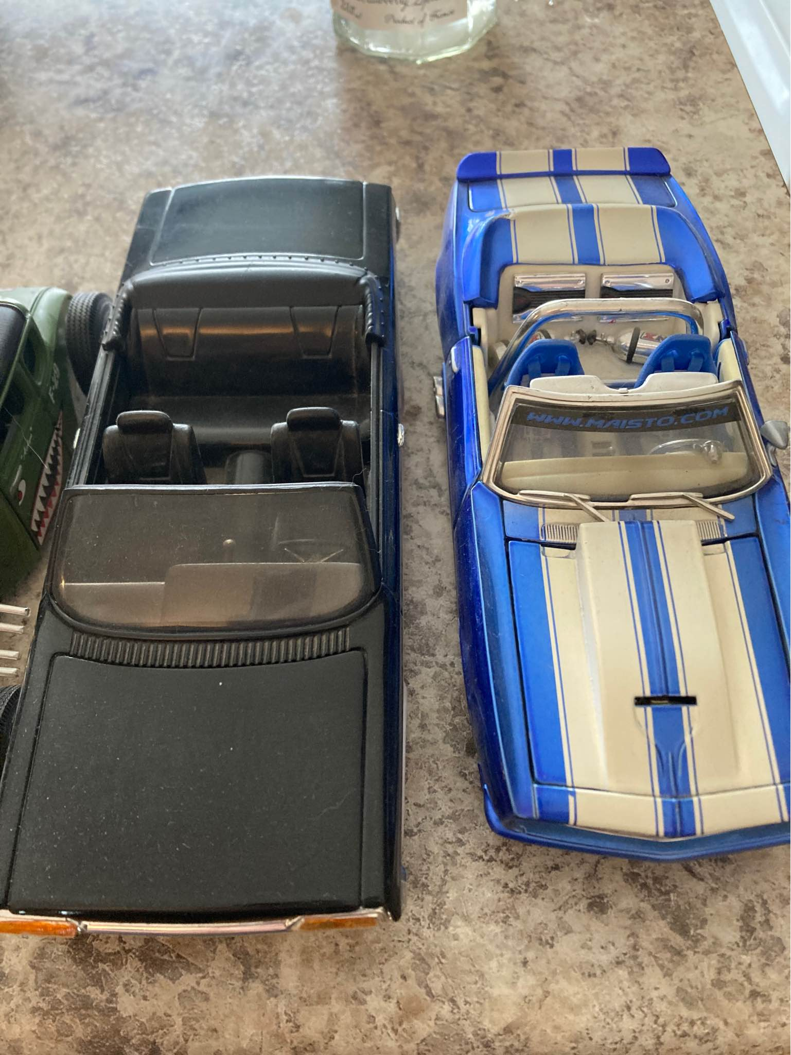**(514) 968-0588**

